Nasee Inc. Analysis Report
Name
Institution

Introduction
Business organizations have a key role in protecting the needs of their employees by ensuring that there is a strong emphasis on better concepts that define an improved change process. Employees form a vital part of any organization, and thus how they have treated means that they are able to participate in organizational development through improved commitment (Allen et al., 2015). The realization that employees are essential to organizational development presents a robust system that helps create a strong emphasis on better processes that help improve the overall organizational development. Managing the needs of employees plays a significant role in ensuring that employees are motivated and empowered. Employee empowerment entails giving employees a certain degree of control and engagement where they are able to make the right decisions based on the underlying tasks (Wirtz & Jerger, 2016). Nasee Inc. is a well-engaged organization that focusses on improving its performance through a higher emphasis on better elements that define a healthy level of development.
However, the company is faced with diverse challenges involving employee management. There have been instances of work slowdown as well as walkout among employees who are unhappy with how the administration has considered improving their level of engagement within the company (Saks, 2015). The level of employee satisfaction presents a better emphasis on the current level of engagement within the company. Therefore the company wishes to determine the degree of employee satisfaction in understanding the influence of the current unrest has on employee commitment. The purpose of this study is to identify specific factors that influence employee satisfaction and develop a better model to help in predicting the degree of employee satisfaction.
Variables
The variables that are included in the study are
Work (satisfaction in their work), which continuous variable measured on an interval scale.
Job Type (Job type) is a discrete variable measured on a nominal scale
Pay (Their pay) is continuous variables measured on a ratio scale
Promo (Their opportunities for promotions) is continuous variables measured on a ratio scale
Educ (Attained level of education) discrete variable measured on an ordinal scale
Location (Work location) is a discrete variable measured on a nominal scale
On the basis of summary table of descriptive statistics (and plots) for the three job satisfaction variables, discuss the job aspects that is most satisfying and least satisfying for the employees. In what area(s), if any, do you feel improvements should be made?
Descriptive statistics

 | WORK | PAY | PROMO
Mean | 71.73529 | 62.48039 | 67.38235
Standard Error | 0.723181 | 1.623558 | 1.141515
Median | 72.5 | 60.5 | 67.5
Mode | 67 | 52 | 76
Standard Deviation | 7.303772 | 16.39713 | 11.52874
Sample Variance | 53.34508 | 268.8659 | 132.9118
Kurtosis | -0.71318 | -0.57032 | -0.81561
Skewness | -0.04029 | 0.171938 | -0.05282
Range | 30 | 73 | 49
Minimum | 56 | 23 | 42
Maximum | 86 | 96 | 91
Sum | 7317 | 6373 | 6873
Count | 102 | 102 | 102

The work satisfaction average was M=71.74±7.3. The minimum satisfaction index was 56, while the highest satisfaction index among employees was 86. Most of the employees had a 67 satisfaction index score based on the mode. The average pay was 62.48±16.4. Most of the employees were being paid 52 while the highest was being paid 96 and the lowest was being paid 23. The average opportunities for promotions were 67 ±11.6. Most of the employees had 76 promo opportunities. The least employee had 42 opportunities, while the highest had 92 chances.
Histogram for work satisfaction

The histogram for work satisfaction shows that most employee satisfaction index is found within 72.5 and 78, although the data is negatively skewed, which means that there is a significant difference in work satisfaction among employees, which indicates that the data is not normally distributed.
Histogram for pay

The histogram for pay shows that the data is positively skewed.
Promotion opportunities histogram

The histogram for opportunities for promotion is negatively skewed which means that the data is not normally distributed.
Therefore based on the assessment of the descriptive statistics, it is clear that there is a significant deviation in pay, considering that the highest-paid employee earns 96 while the lowest-paid employee is earning 23. The considerable variation is likely to have a negative influence on employee work satisfaction levels. There is also deviation on the number of opportunities for promoting the highest employee who had 76 opportunities, and the lowest had 42 opportunities despite working in the same company where it is expected that employees have relatively equal chances for promotion.

On the basis of descriptive measures of variability, determine the job satisfaction that appears to generate the greatest and the least difference of opinions among the employees?
Based on the descriptive measures of variability, employee pay had the greatest variability with a standard deviation of 16.4, while employee work satisfaction had the least variation with a standard deviation of 7.3.
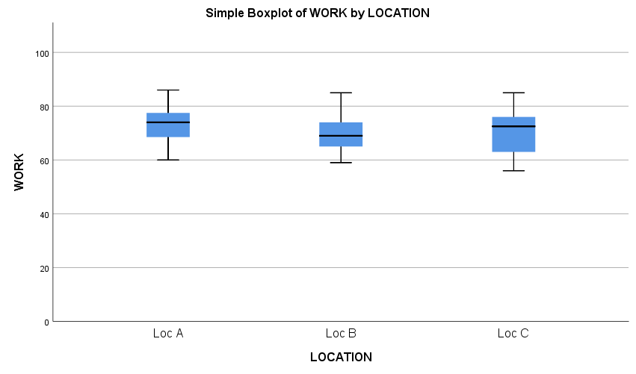
The boxplot of work satisfaction and location shows that employees from Location A had a high work satisfaction index while employees from Location B had the lowest satisfaction index.

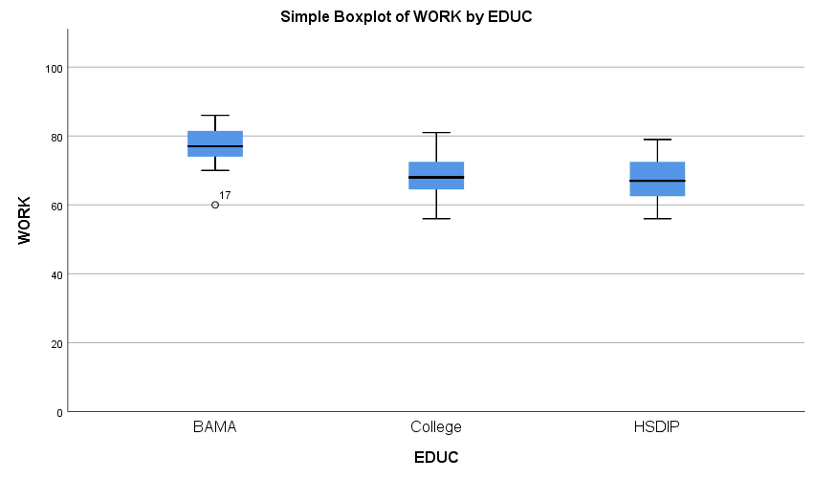
The analysis of work satisfaction and education level showed that employees who had a Bachelors or Master's degree (BAMA) had the highest job satisfaction while High School Diploma (HSDIP) employees were least satisfied.

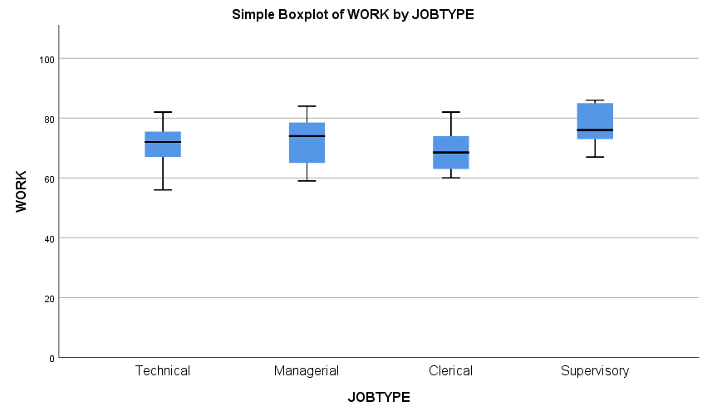

Employees at the managerial role had a high satisfaction index followed by supervisory while clerical employees were least satisfied with their work.

Use the contingency table analysis to test the hypotheses that
(i) The type of employee’s job and level of employee’s attained education are independent.
Contingency table
Row Labels | BAMA | COLLEGE | HSDIP | Grand Total
CLERICAL | 6 | 7 | 9 | 22
MANAGERIAL | 9 | 11 | 3 | 23
SUPERVISORY | 12 | 3 | 2 | 17
TECHNICAL | 12 | 19 | 9 | 40
Grand Total | 39 | 40 | 23 | 102

Hypothesis (Ho): Type of employee’s job and level of employee’s attained education are independent.
Results
 | BAMA | College | HSDIP | Row Totals
Clerical | 6 (8.41) [0.69] | 7 (8.63) [0.31] | 9 (4.96) [3.29] | 22
Managerial | 9 (8.79) [0.00] | 11 (9.02) [0.43] | 3 (5.19) [0.92] | 23
Supervisory | 12 (6.50) [4.65] | 3 (6.67) [2.02] | 2 (3.83) [0.88] | 17
Techncal | 12 (15.29) [0.71] | 19 (15.69) [0.70] | 9 (9.02) [0.00] | 40
Column Totals | 39 | 40 | 23 | 102 (Grand Total)

The Chi-Squared statistic is computed as follows:
i=1∑n​Eij​(Oij​−Eij​)2​=0.691+0.005+4.654+0.71+0.307+0.435+2.017+0.7+3.289+0.922+0.877+0
χ2=14.605
p -value from tables = 0.023557.
Thus p<0.05 thus we reject the null hypothesis and conclude that Type of employee’s job and level of employee’s attained education are dependent.
(ii) The type of employee’s job and employee’s work location are independent.
Contingency table
Row Labels | Loc_A | Loc_B | Loc_C | Grand Total
CLERICAL | 9 | 11 | 2 | 22
MANAGERIAL | 9 | 8 | 6 | 23
SUPERVISORY | 13 | 2 | 2 | 17
TECHNICAL | 13 | 11 | 16 | 40
Grand Total | 44 | 32 | 26 | 102

Hypothesis
H0​: The Job type and Location are independent
Expected Values:
9.5 6.9 5.6
9.9 7.2 5.9
7.3 5.3 4.3
17.2 12.5 10.2
i=1∑n​Eij​(Oij​−Eij​)2​ = 0.025 + 2.43 +2.3 +0.086 + 0.085 + 0.0032+4.38 +2.08 + 1.26 +1.05 + 0.19 + 3.3
χ2=17.21
Degrees of freedom = 6
p-value = 0.008
Therefore p<0.05 hence we reject the null hypothesis and conclude that the Job type and Location are dependent.
(iii) The level of employee’s attained education and employee’s work location are independent.
Contingency table
Row Labels | Loc_A | Loc_B | Loc_C | Grand Total
BAMA | 23 | 8 | 8 | 39
COLLEGE | 13 | 17 | 10 | 40
HSDIP | 8 | 7 | 8 | 23
Grand Total | 44 | 32 | 26 | 102

Hypothesis (Ho): Level of employee’s attained education and employee’s work location are independent.
Expected Values:
16.8235 12.2353 9.94118
17.2549 12.549 10.1961
9.92157 7.21569 5.86275
i=1∑n​Eij​(Oij​−Eij​)2​ = 2.27 + 1.47+ 0.379+1.05 + 1.58+ 0.004+0.37+ 0.006+ 0.78
χ2=7.9
P-value from the table = 0.095
Therefore p>0.05 hence we fail to reject the null hypothesis and conclude level of employee's attained education and employee's work location are independent.

Question 5
Develop and discuss the 95% confidence interval estimates of job satisfaction (work, pay and promotion) for
(i) all employees;
 | Work | Pay | Promo
Mean | 71.74 | 62.48 | 67.38
Confidence level (95%) | 1.434597 | 3.22 | 2.26
Upper Confidence interval | 73.17 | 65.701 | 69.65
Lower confidence interval | 70.3007 | 59.26 | 65.12

(ii) employees from each location;
Location A
 | WORK | PAY | PROMO
Mean | 73.54545 | 67.90909 | 70.72727
Confidence Level (95.0%) | 2.122079 | 4.829327 | 3.554845
Lower Confidence interval | 71.42338 | 63.07976 | 67.17243
Upper confidence interval | 75.66753 | 72.73842 | 74.28212

Location B
 | WORK | PAY | PROMO
Mean | 70.30769 | 58.76923 | 65
Confidence Level (95.0%) | 3.138595 | 6.100287 | 4.814484
Lower Confidence Interval | 67.1691 | 52.66894 | 60.18552
Upper confidence Interval | 73.44629 | 64.86952 | 69.81448

Location C
 | WORK | PAY | PROMO
Mean | 70.30769 | 58.76923 | 65
Confidence Level (95.0%) | 3.138595 | 6.100287 | 4.814484
Lower confidence level | 67.1691 | 52.66894 | 60.18552
Upper confidence level | 73.44629 | 64.86952 | 69.81448

The analysis of the location of employees identifies that location A has a higher average of all the key factors of job satisfaction that were being investigated. The confidence interval for work satisfaction was 95% CI [71.42, 75.67]. The confidence interval for pay was 95% CI [63.08, 72.73]. The confidence interval for promotion opportunities was 95% CI [67.17, 74.28].

(iii) employees from each job type;
Managerial
 | WORK | PAY | PROMO
Mean | 72.34783 | 61.08696 | 68.65217
Confidence Level(95.0%) | 3.171314 | 5.394644 | 4.781012
Lower Confidence Interval | 69.17651 | 55.69231 | 63.87116
Upper Confidence Interval | 75.51914 | 66.4816 | 73.43319

Supervisory
 | WORK | PAY | PROMO
Mean | 77 | 76 | 75.47059
Confidence Level(95.0%) | 3.769478 | 9.508348 | 5.719926
Lower Confidence Interval | 73.23052 | 66.49165 | 69.75066
Upper Confidence Interval | 80.76948 | 85.50835 | 81.19051

Clerical
 | WORK | PAY | PROMO
Mean | 69.09091 | 57.77273 | 63.40909
Confidence Level(95.0%) | 3.068467 | 6.491692 | 4.805895
Lower Confidence Interval | 66.02244 | 51.28104 | 58.6032
Upper Confidence Interval | 72.15938 | 64.26442 | 68.21499

Technical
WORK
Mean | 70.6 | 60.125 | 65.4
Confidence Level(95.0%) | 2.082488 | 5.094544 | 3.485993
Lower Confidence Interval | 68.51751 | 55.03046 | 61.91401
Upper Confidence Interval | 72.68249 | 65.21954 | 68.88599

The analysis of job type showed that supervisory employees were the most satisfied, based on the confidence interval analysis. The confidence interval for work satisfaction was 95% CI [73.2, 80.77]. The confidence interval for pay was 95% CI [66.49, 85.51]. The confidence interval for promotion opportunities was 95% CI [69.75, 81.19].

(iv) employees from each education level
BAMA
 | WORK | PAY | PROMO
Mean | 77.58974 | 78.35897 | 77.58974
Confidence Level (95.0%) | 1.716464 | 3.242041 | 2.291835
Lower Confidence Interval | 75.87328 | 75.11693 | 75.29791
Upper Confidence Interval | 79.30621 | 81.60101 | 79.88158

College
 | WORK | PAY | PROMO
Mean | 68.525 | 55.2 | 61.85
Confidence Level (95.0%) | 1.804777 | 2.476433 | 2.913703
Lower Confidence Interval | 66.72022 | 52.72357 | 58.9363
Upper Confidence Interval | 70.32978 | 57.67643 | 64.7637

HSDIP
 | WORK | PAY | PROMO
Mean | 67.3913 | 48.21739 | 59.69565
Confidence Level (95.0%) | 2.76197 | 6.104328 | 3.734599
Lower Confidence Interval | 64.62933 | 42.11306 | 55.96105
Upper Confidence Interval | 70.15327 | 54.32172 | 63.43025

The analysis of factors of job satisfaction and level of education showed that the Bachelors and Masters (BAMA) level of education employees were more satisfied than the other employees in the other groups. The confidence interval for work satisfaction was 95% CI [75.87, 79.31]. The confidence interval for pay was 95% CI [75.12, 81.6]. The confidence interval for promotion opportunities was 95% CI [75.3, 79.88].

Suppose that an employee is ‘dissatisfied’ with the job if the degree of satisfaction for at least one of the 3 expressed satisfactions (work, pay or promotion) is less than 70. Perform tests to determine if employees are dissatisfied with their job
Hypothesis
Ho: Average pay is greater than 70
Ha: Average pay is less than 70
One-Sample Test
 | Test Value = 70
 | t | df | Sig. (2-tailed) | Mean Difference | 95% Confidence Interval of the Difference
 |  |  |  |  | Lower | Upper
PAY | -4.632 | 101 | .000 | -7.520 | -10.74 | -4.30

Thus in order to determine whether the average employee pay is less than 70, a one-sample t-test was performed, which showed that the p<0.01 hence we reject the null hypothesis and conclude that the average pay for employees is less than 70.
What can be said about the relationships between the job satisfaction variables? Discuss on the basis of scatter plots and correlations of the relevant variables
The correlation analysis shows that there is a very strong positive correlation between work satisfaction and promotion opportunities (r = 0.88). The scatterplot shows a positive linear relationship between work satisfaction and promotion opportunities. The analysis also showed that there was a strong positive relationship between work satisfaction and employee pay (r = 0.64). The Scatterplot indicates that there is a strong positive linear relationship between work satisfaction and pay.
 | WORK | PAY | PROMO
WORK | 1
PAY | 0.638564 | 1
PROMO | 0.882509 | 0.709022 | 1

Scatterplot between work satisfaction and pay

Scatterplot between work satisfaction and Promo

Do your results suggest any recommendations for learning about and/or improving job satisfaction? Discuss based on your results from 1 to 7.
The findings from the analysis show that work satisfaction is influenced by different factors, with pay and promotion opportunities being significant factors that are associated with a change in employment opportunities. The average pay is less than 70, which means that there is a high likelihood that unequal pay among employees within the company is one of the reasons leading to employee unrest and reduced work satisfaction. However, generally, the company has maintained a steady work satisfaction based on employee satisfaction, which has an average of 71 from a possible 100. However, work satisfaction should be extremely high to allow employees to focus on their tasks. The company should, therefore, focus on rationalizing employee pay and ensure that the available promotional opportunities are increased. All employees should be considered to attain better outcomes and control the current standoff between employee and management.

.

References
Saks, A. (2015). Managing Performance Through Training & Development, (Canadian ed.). Nelson Education.
Noe, R. A., Hollenbeck, J. R., Gerhart, B., & Wright, P. M. (2017). Human resource management: Gaining a competitive advantage. New York, NY: McGraw-Hill Education.
Wirtz, J., & Jerger, C. (2016). Managing service employees: Literature review, expert opinions, and research directions. The Service Industries Journal, 36(15-16), 757-788.
Allen, M. R., Adomdza, G. K., & Meyer, M. H. (2015). Managing for innovation: Managerial control and employee level outcomes. Journal of Business Research, 68(2), 371-379.

